For the purpose of maintainability, we have opted to use embedding youtube videos as our method of adding videos to a page. In order to embed a video from youtube, the video must first be available on youtube.

To upload a video to youtube is simple, in fact, follow the steps in this youtube video tutorial to upload a video! <https://www.youtube.com/watch?v=aHocQeo9ibY&feature=youtu.be>

Next, you’ll want to log in to wordpress, and find the page you want to add a video to by clicking on “Pages” in the dashboard.



When you’ve clicked pages you should be presented with a list of existing pages. Find the one you’d like to add a video to and hover your mouse over the page. You will get a list of options like the one in the figure below:  
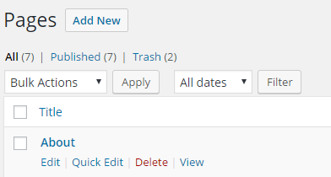  
  
Click “Edit” to edit the page.

You should now see a the page you’ve selected in the page editor as shown below:  
  
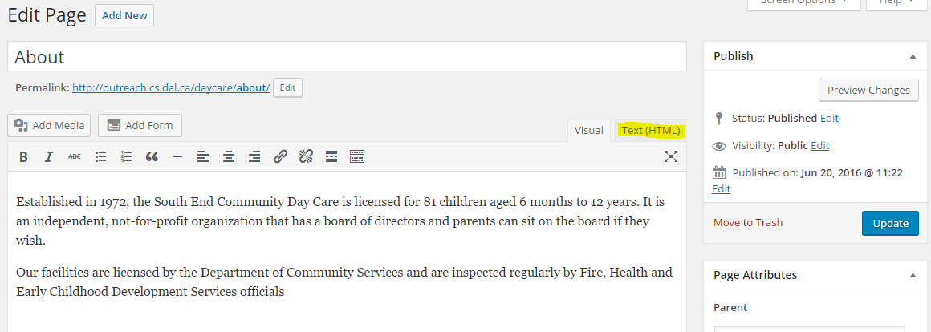  
  
Click on the tab “Text(HTML).  
  
You should now see the same content, but it might look a little less polished, that is OK.

In another window or browser tab, find the youtube video you’d like to add to your website.

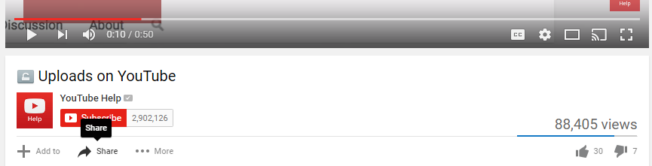

Scroll to the bottom of the video and click “Share”.

You should now see this menu:



Click on “Embed” and copy the highlighted section below.

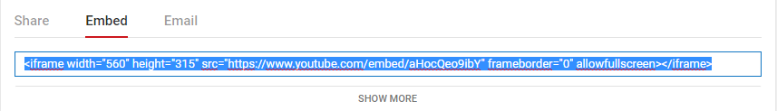

Head back to your wordpress page and paste the contents where you’d like to see them in the page. An example is below:

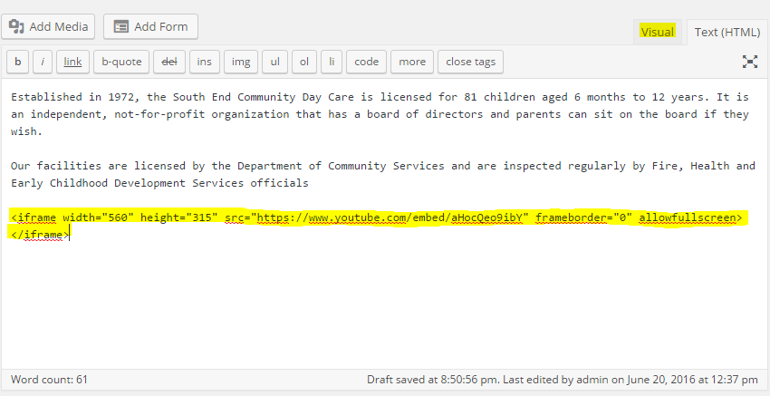

Click the “Visual” tab in the editor to see a preview of the video in the page.



If you are happy with the page, click “Save” to publish the content!